

Security Onion Project

INTRODUCTION:
Security Onion is a free and open-source Linux distribution focused on network security monitoring, intrusion detection, and log management. It is a complete solution for the detection, analysis, and response to various cyber threats on the network of an organization. Security Onion incorporates robust security tools such as Suricata for intrusion detection systems, Zeek for network traffic analysis, the Elastic Stack for log management, and Wazuh for host-based intrusion detection systems. It captures network traffic and analyzes it in real-time, enabling security experts to detect suspicious activities on the network and improve the overall security posture of the network. Security Onion is a powerful tool for Security Operation Centers (SOCs), enterprise networks, and cybersecurity training environments. The project focuses on the implementation of Security Onion in a virtual lab environment for simulating attacks and carrying out incident analysis.

Problem Statement:
In today’s computerized world, organizations depend on computer networks and internet-based technologies for their day-to-day activities. However, the rapid development of computer technologies has also resulted in the emergence of various cyber threats and security incidents such as malware attacks, unauthorized access, brute-force attacks, phishing, and network intrusion. Traditional security solutions such as firewalls and antivirus solutions are not capable of detecting sophisticated and modern types of cyber threats and security incidents in real-time. Moreover, many organizations do not have proper network monitoring solutions to identify security incidents before they occur.
There is a need to design and implement an effective Network Security Monitoring and Intrusion Detection System to monitor network activities and identify security incidents. This project is designed to resolve the problem of network security monitoring and intrusion detection. This project will implement the Security Onion as an effective security solution to enhance network security monitoring and intrusion detection capabilities in a controlled environment.

Objectives of the Project:
The main objective of this project is to design and implement a Network Security Monitoring and Intrusion Detection system using Security Onion in a virtual lab environment. The specific objectives of the project are as follows:
- To deploy and configure Security Onion in a virtualized environment for network monitoring.
- To simulate real-world cyber attacks such as port scanning and brute-force attacks.
- To detect and analyze intrusions using Suricata and Zeek.
- To collect, store, and analyze logs using the Elastic Stack dashboard.
- To monitor alerts and investigate suspicious activities through the SOC interface.
- To generate incident reports and recommend mitigation strategies.
- To gain practical knowledge of Security Operations Center (SOC) workflow and threat detection techniques.

INSTALLATION:
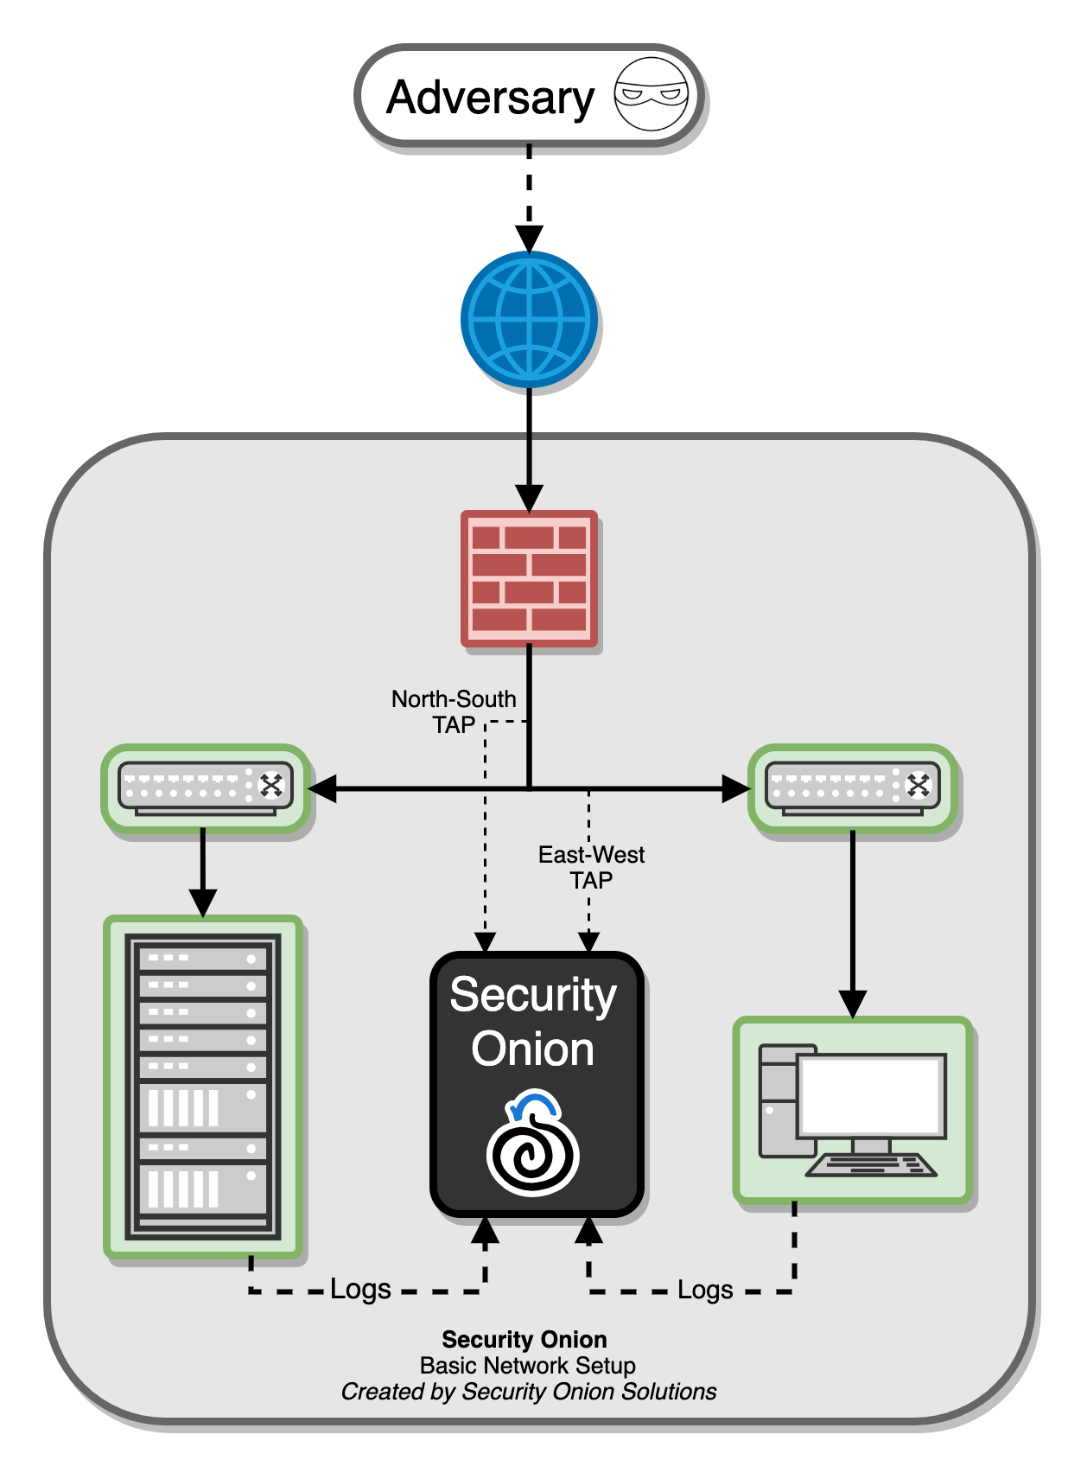
STEP 1:
Download the Security Onion ISO File
To begin the installation of Security Onion, you must first download the official ISO image (installation file) from the official source. Also in network adapter option add two network adapter
Link: https://github.com/Security-Onion-Solutions/securityonion/releases/tag/2.4.210-20260302
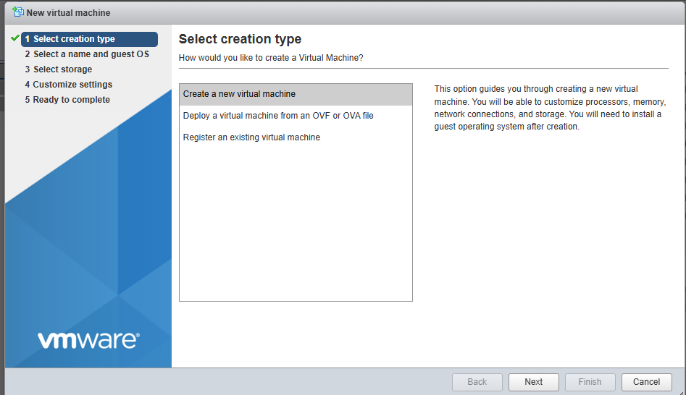
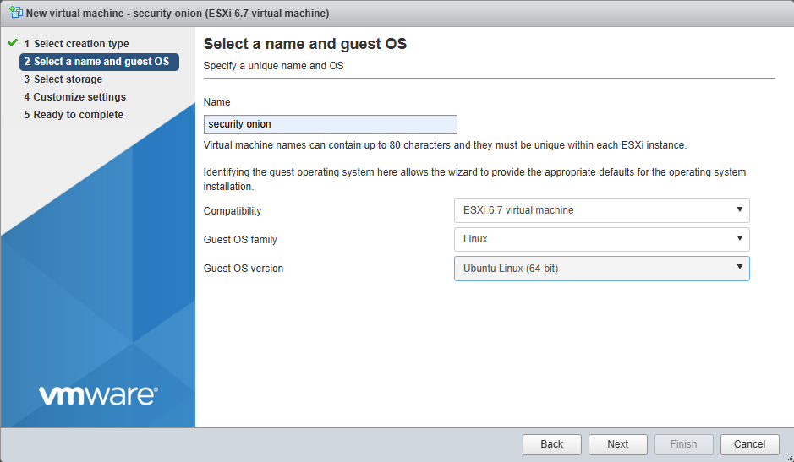
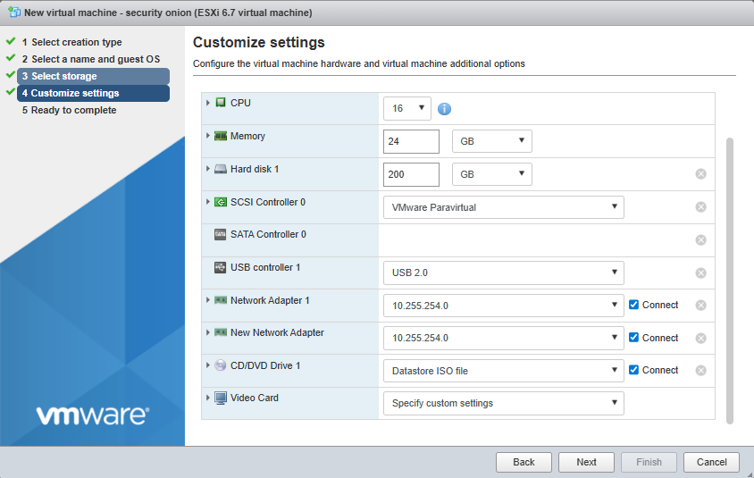
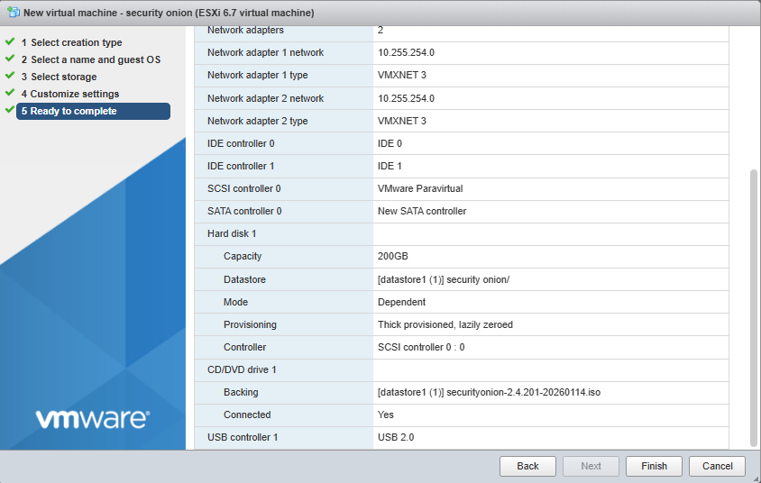

STEP 2:
Booting the ISO and Starting Installation
After downloading the Security Onion ISO file, the ISO was mounted in a virtual machine. Upon booting, the installation menu appeared with multiple options. The standard installation option “Install Security Onion 2.4.201” was selected to proceed with the setup. This option installs the complete Security Onion platform required for network monitoring and intrusion detection in a standalone lab environment.
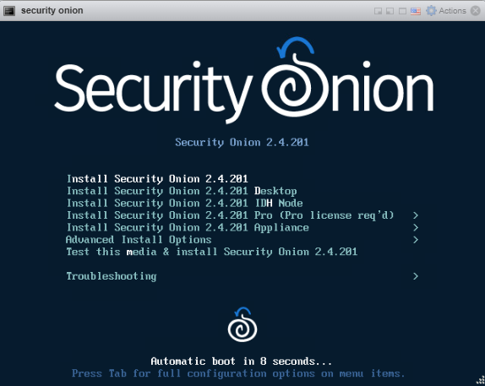

STEP 3:
Creating Administrative User
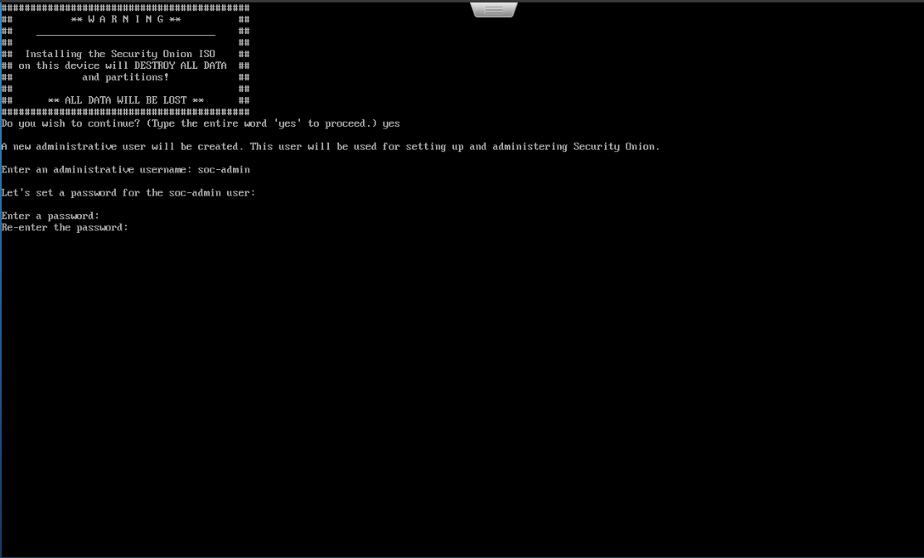
During installation, the system prompted for confirmation before erasing all disk data. After typing “yes,” a new administrative user account was created for managing Security Onion. The username “socadmin” was configured, and a strong password was set to ensure secure access to the system. This account will be used for logging into the Security Onion management interface and performing administrative tasks.

STEP 4:
Installation Completion and System Reboot
Once the admin username and password were entered, the installation was completed automatically. The installation configured the boot loader, network settings, and any required services. It then proceeded with the automatic reboot. Once the system was restarted, the ISO file was removed to enable the system to boot from the installed Security Onion environment.
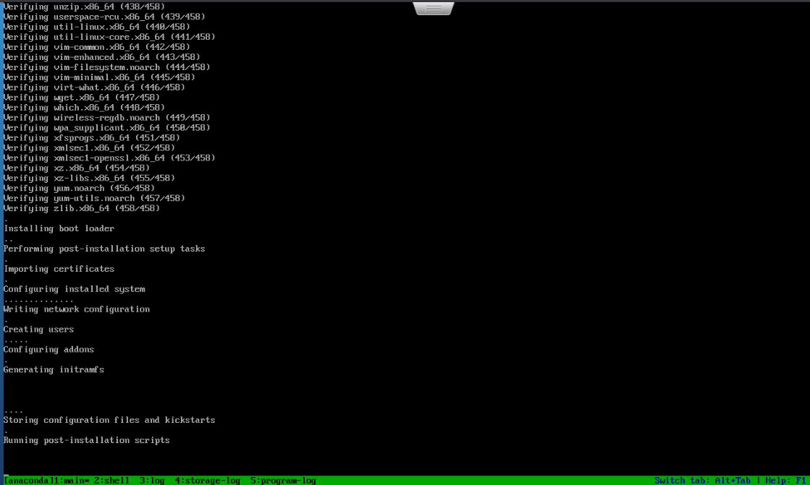

STEP 5:
Starting Security Onion Setup
- After system reboot, logged in using the created administrative credentials.
- Executed the command sudo so-setup to start the configuration wizard.
- The Security Onion welcome screen appeared with setup information.
- Reviewed the deployment options (Standalone and Distributed).
- Selected “Yes” to proceed with the setup process.


STEP 6 :
Selecting Installation Type
- Selected Install to run the standard Security Onion installation.
- Chose Evaluation Mode (EVAL) for lab and testing purposes.
- Evaluation mode is recommended for non-production environments.
- Read the Elastic License Version 2 (ELv2) agreement.
- Typed AGREE to accept the license terms and continue the setup.
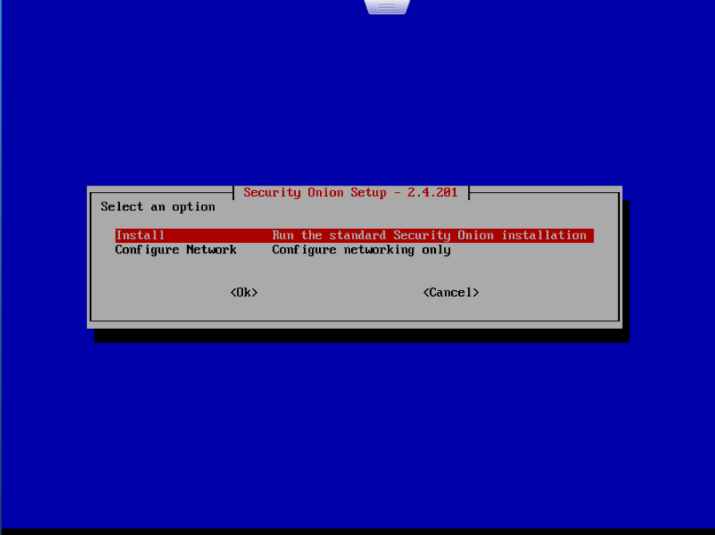

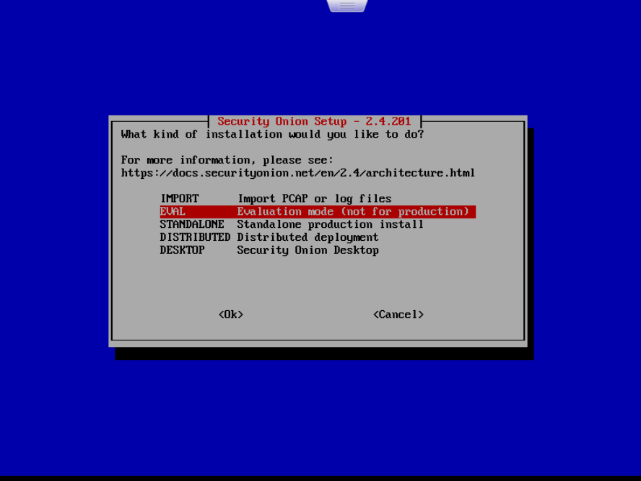

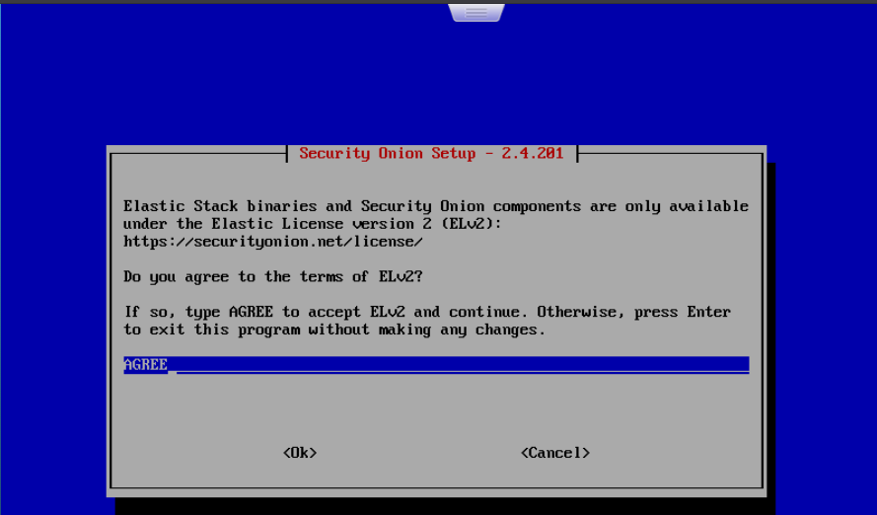

STEP 7:
Configuring Node Type, Hostname, and Network Interface
- Selected Standard installation (node has Internet access).
- Chose Standard instead of Airgap since the lab system has internet connectivity.
- Entered the hostname as SOC for system identification.
- Selected the primary network interface (ens192) for management.
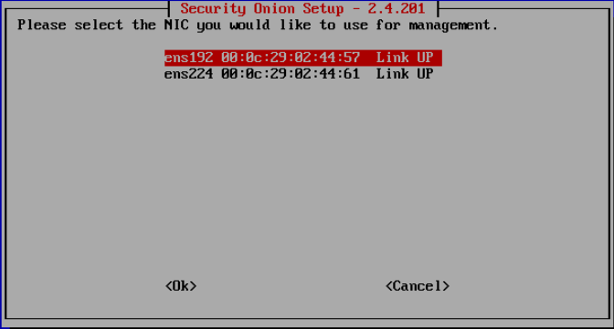
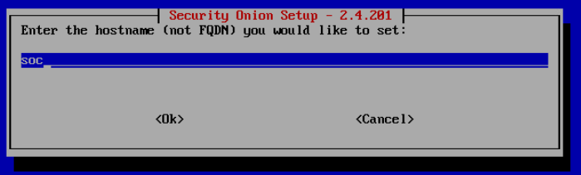
- Confirmed the selected NIC (Link UP) to continue configuration.
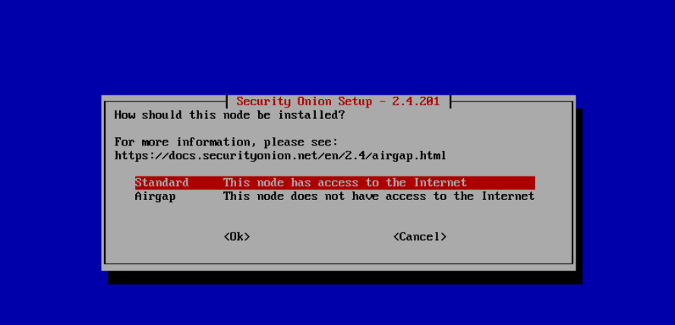

STEP 8:
Configuring Static IP Address and Network Settings
In this step, the management network interface of Security Onion was configured using a static IPv4 address. A static IP address is recommended because it ensures consistent and reliable access to the Security Onion management interface and web dashboard.
1. Selecting IP Configuration Method
- The setup wizard prompted to choose how the management interface should be configured.
- The “STATIC – Set a static IPv4 address (recommended)” option was selected.
- Static configuration is preferred in SOC environments to avoid IP address changes caused by DHCP.
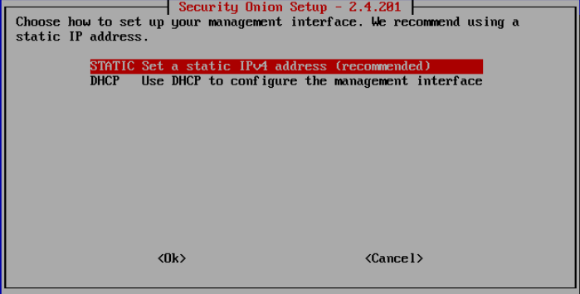
2. Assigning IPv4 Address
- The system requested an IPv4 address in CIDR format.
- The following IP address was assigned:
- 10.47.2.25 is the host IP address.
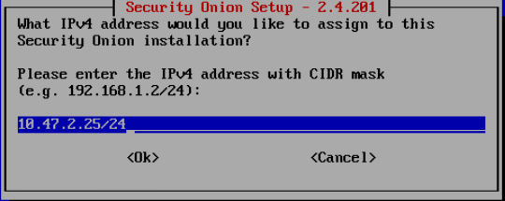

3. Configuring Default Gateway
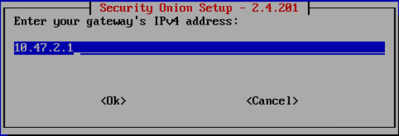
- The gateway IP address was entered as:

4. Configuring DNS Servers
- DNS server addresses were entered to enable domain name resolution.
- The following public DNS servers were configured:
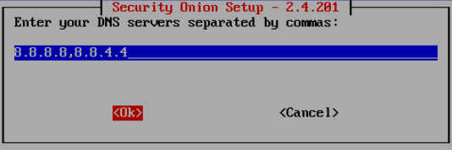

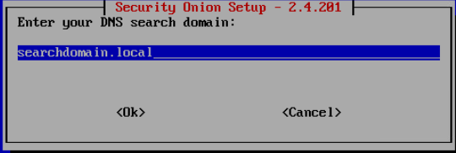

STEP 9:
Internet, Monitor Interface & SOC Account Setup
- Selected Direct connection for internet access.
- Chose Direct because the lab environment has normal internet connectivity.
- Clicked OK to proceed.
- Selected ens224 as the Monitor Interface (sensor NIC).
- Enabled the interface to capture network traffic.
- Confirmed the NIC selection and continued.
- Entered an email address to create the SOC administrator account.
- This email is used for SOC web interface, Elasticsearch, and Kibana login.
- Set a strong password for the SOC admin account.
- Confirmed the password and selected OK to continue.

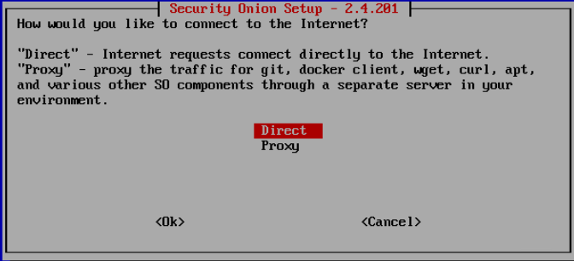

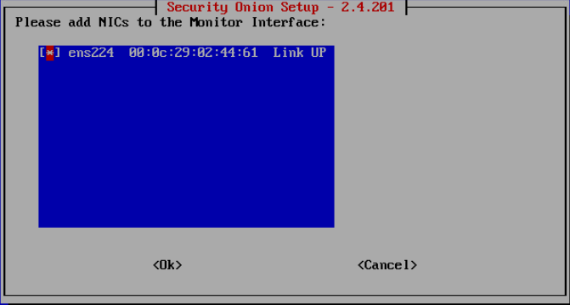

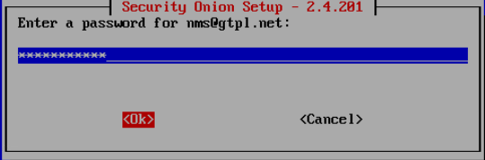
STEP 10: Enter The IP Range To Allow and Give okay and exit
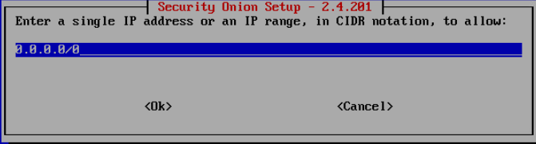
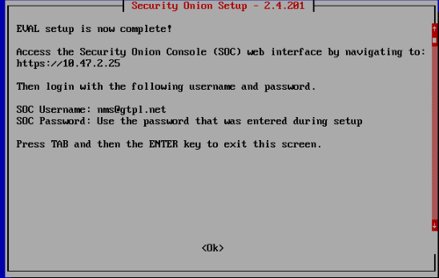

Enter the command in cli and check status of all services
Command: sudo so-status

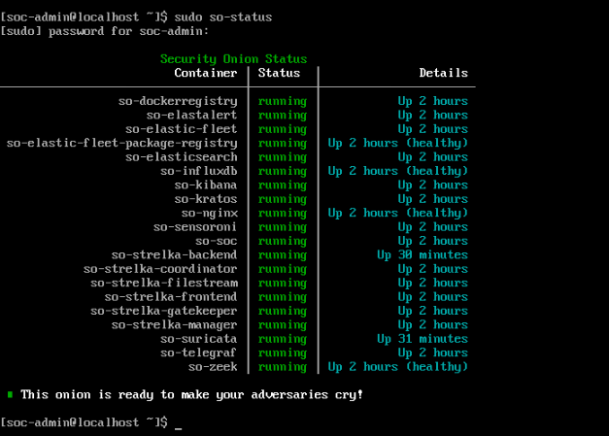
STEP11:
Enter the url in web browser https://<host ip> and check all tools are installed in security onion

